Data Cleaning Process – PJM Hourly Energy Consumption Dataset
Prepared by: Helen (Yaqiao) – for team reference, ICT30016 ICT Innovation Project

1. Why We Clean This Dataset First
We are using three public datasets in this project: PJM Hourly Energy Consumption, Household Electric Power Consumption, and Real-E. We chose to clean PJM first and treat it as our primary dataset for these reasons:
- It is grid-level data (not a single household), which matches our client’s focus on grid operators.
- Its structure is simple (only a timestamp column and a power value column), so it is a good dataset to build and test our cleaning pipeline on first.
- Once this pipeline works, we can reuse the same logic (with small adjustments) for the other two dataset. This is the dame idea as “R2” in our risk register: build the pipeline once, then create wrappers for the other datasets.

2. Dataset Source
Dataset: PJM Hourly Energy Consumption (Kaggle)
Link: https://www.kaggle.com/datasets/robikscube/hourly-energy-consumption?resource=download
File used: PJME_hourly.csv (PJM East region – the largest and most commonly used file in this dataset)
Columns: Datetime (timestamp), PJME_MW (hourly power consumption in megawatts)

3. Environment Setup
We use VS Code with a Jupyter Notebook (.ipynb file) for data cleaning. This does not need GPU, so we do not use Google Colab for this step. Colab is kept for LSTM model training later.
We use a project-specific virtual environment (venv) so that everyone on the team runs the exact same Python version and library versions. We use Python 3.12, because it has stable support for pandas, scikit-learn, XGBoost, and TensorFlow (very new Python versions like 3.14 do not support some of these libraries yet).
Step | Windows (PowerShell) | Mac (Terminal)
Check Python version | py -3.12 --version | python3.12 --version
Create virtual environment | py -3.12 -m venv .venv | python3.12 -m venv . venv
Activate virtual environment | .venv\Scripts\activate | source .venv/bin/activate
Install libraries | pip install pandas numpy | pip install pandas numpy

After activating the environment, install the required libraries:
pip install pandas numpy

In VS Code, open the notebook file and select this virtual environment as the Kernel (top-right corner of the notebook - Select Kernel Python Environments choose the .venv you just created).

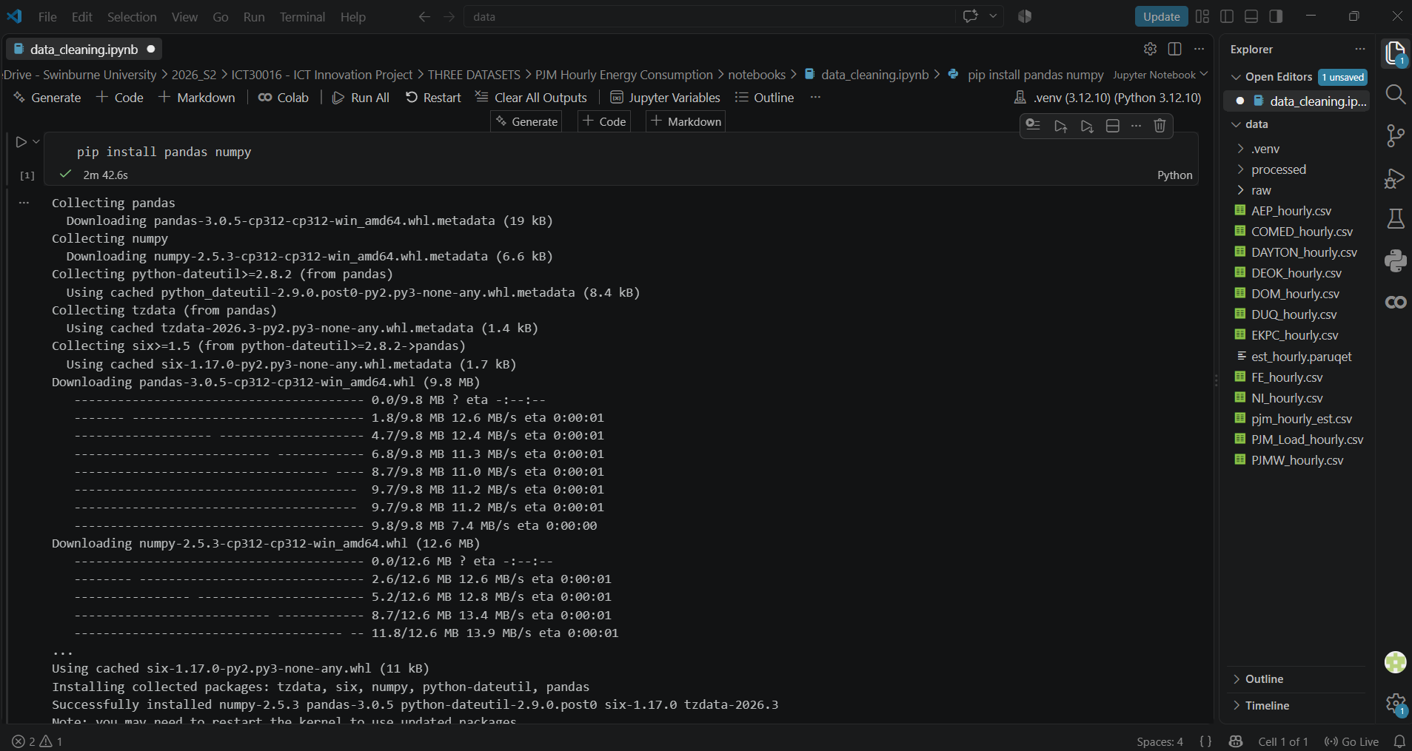

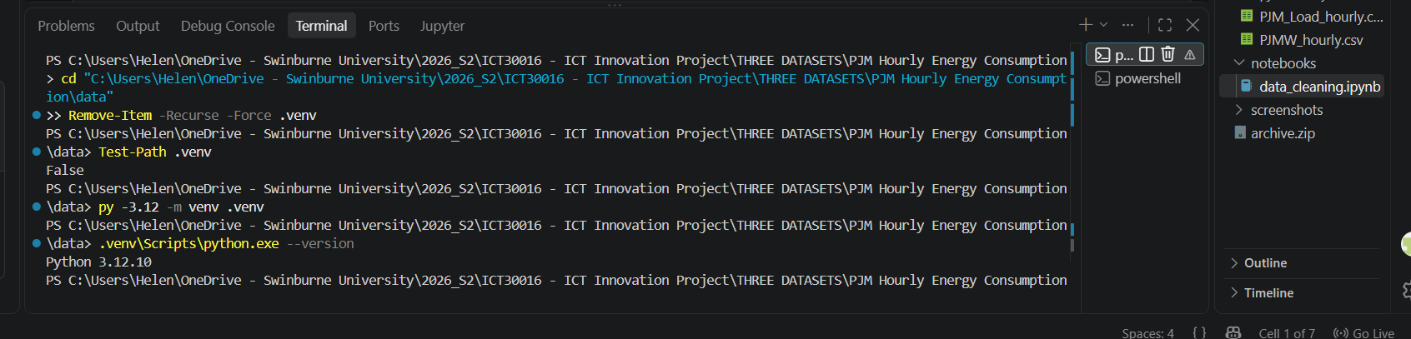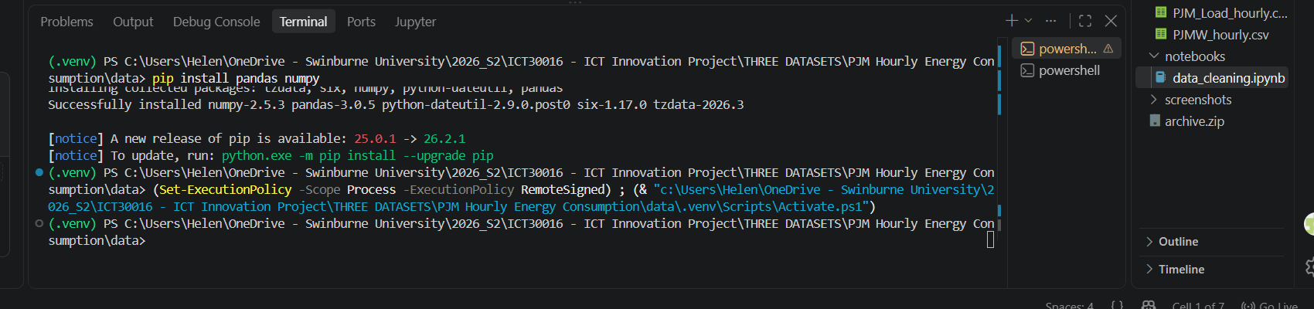

4. Cleaning Steps (Code)
The notebook file is: notebooks/data_cleaning.ipynb. Run the cells below in order, from top to bottom.

Cell 1 – Load and inspect the data
import pandas as pd

df = pd.read_csv("../data/raw/PJME_hourly.csv")
print(df.shape)
print(df.head())
print(df.dtypes)

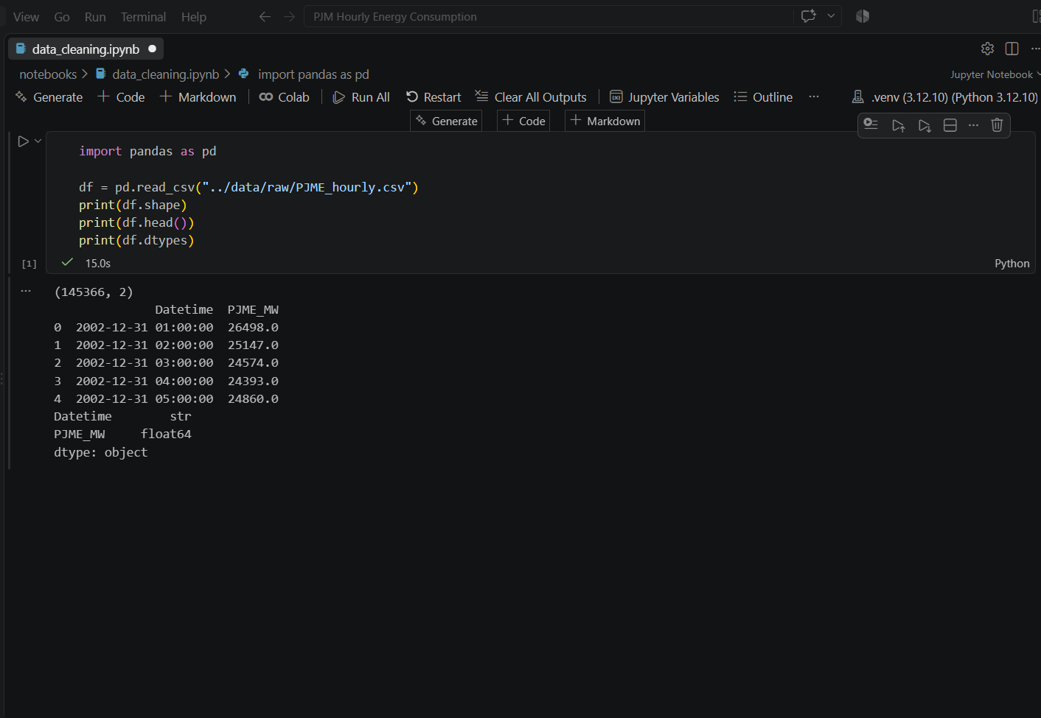

Cell 2 — Convert timestamp and sort

df['Datetime'] = pd.to_datetime(df['Datetime'])
df = df.sort_values('Datetime').reset_index(drop=True)

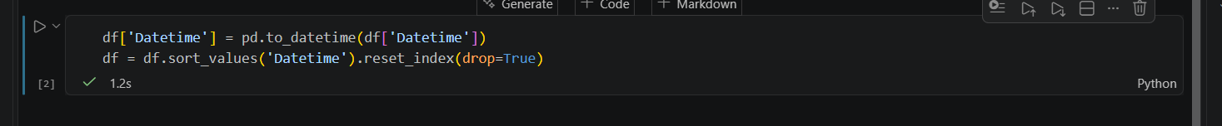

Cell 3 — Check and remove duplicate timestamps
duplicates = df[df.duplicated(subset='Datetime', keep=False)]
print(f"Found {len(duplicates)} duplicate timestamp rows")

# Keep the first occurrence, drop the rest
df = df.drop_duplicates(subset='Datetime', keep='first')
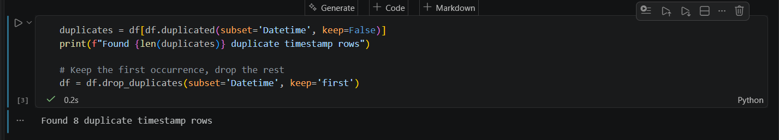

Cell 4 — Check for missing hours (gaps in the timeline)
full_range = pd.date_range(start=df['Datetime'].min(), end=df['Datetime'].max(), freq='h')
missing_hours = full_range.difference(df['Datetime'])
print(f"Missing {len(missing_hours)} hours out of {len(full_range)} expected hours")

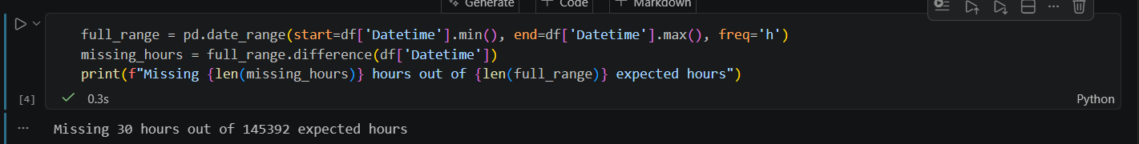

Cell 5 — Check for outliers
print(df['PJME_MW'].describe())

# Simple outlier check: negative values, or values far above the normal range
suspicious = df[(df['PJME_MW'] <= 0) | (df['PJME_MW'] > df['PJME_MW'].quantile(0.999) * 1.5)]
print(f"Found {len(suspicious)} suspicious values")

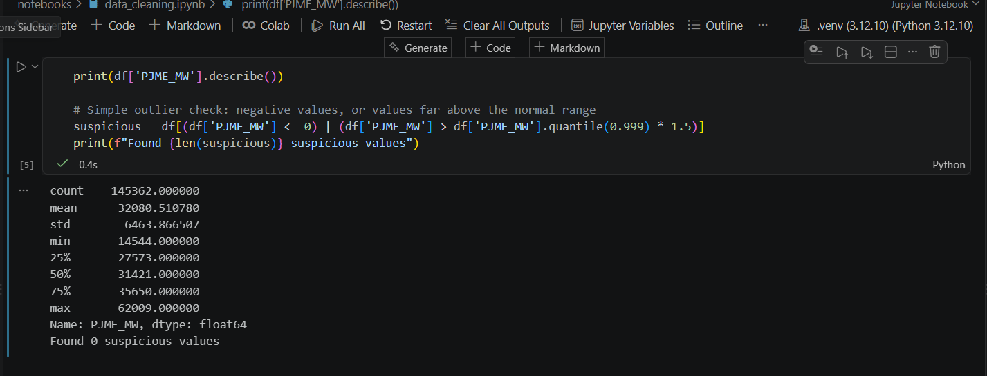

Cell 6 — Fill missing hours using interpolation
df = df.set_index('Datetime').reindex(full_range)
df['PJME_MW'] = df['PJME_MW'].interpolate(method='time')
df = df.reset_index().rename(columns={'index': 'Datetime'})

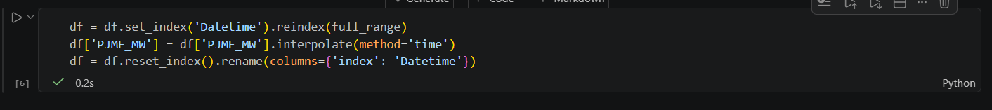

Cell 7 — Save the cleaned dataset
df.to_csv("../data/processed/PJME_hourly_cleaned.csv", index=False)
print("Cleaned dataset saved successfully.")

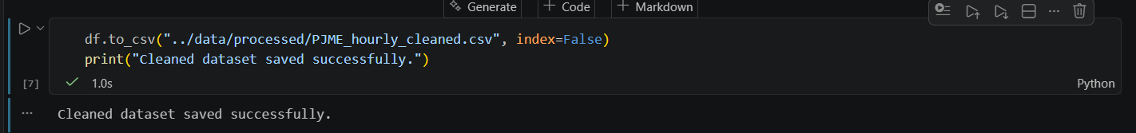

5. Results
Check | Result
Total rows | 145,366 rows (Jan 2022 – Aug 2018)
Duplicate timestamps found | 8 rows (all on daylight-saving clock-back days in November)
Missing hours found | 30 hours out of 145,392 expected hours (0.021%)
Outliers / invalid values | 0 found (no negative or extreme values, no missing values)
Conclusion | Data quality is good. Only small fixes were needed.

The cleaned file is saved at: data/processed/PJME_hourly_cleaned.csv

6. Next Steps
- Reuse this same pipeline structure for the Household Electric Power Consumption and Real-E datasets (adjust column names and formats as needed).
- This process (and these exact numbers) can be used directly in the “Data collection and preprocessing” step of Section 3.2 Technical Workflow in the Methodology.
- Exploratory Data Analysis (EDA) : trends, seasonality, daily/weekly patterns, is the next task after cleaning.

